Flattening a Linked List

Problem Statement: Given a linked list containing ‘N’ head nodes where every node in the linked list contains two pointers:
- ‘Next’ points to the next node in the list
- ‘Child’ pointer to a linked list where the current node is the head
Each of these child linked lists is in sorted order and connected by a 'child' pointer. Your task is to flatten this linked list such that all nodes appear in a single layer or level in a 'sorted order'.
Optimal Approach
Algorithm / Intuition
The time and space complexity of the previous approach can be optimised as we have not yet leveraged the given property that the child linked lists are sorted. We can eliminate the additional space and time complexity generated by sorting by using these sorted vertical linked lists.
Instead of collecting all node values into an array and then sorting them, we can merge these pre-sorted lists directly during the traversal, eliminating the need for additional sorting steps. This merge operation can be performed efficiently in place without allocating extra space for the combined linked list.
Read more about Merging Sorted Linked Lists. The base case ensures the termination of the recursion when there's either no list or only a single node remaining. The recursive function then handles the merging of the remaining lists after recursive flattening, creating a sorted flattened linked list.
Algorithm
Base Case:
- If the head is null, indicating the end of the list, it is already flattened or there are no further nodes. Return the head as it is.
- Similarly, if there's no next node, meaning there's only one node left in the list, return the head as it is since it's already flattened.
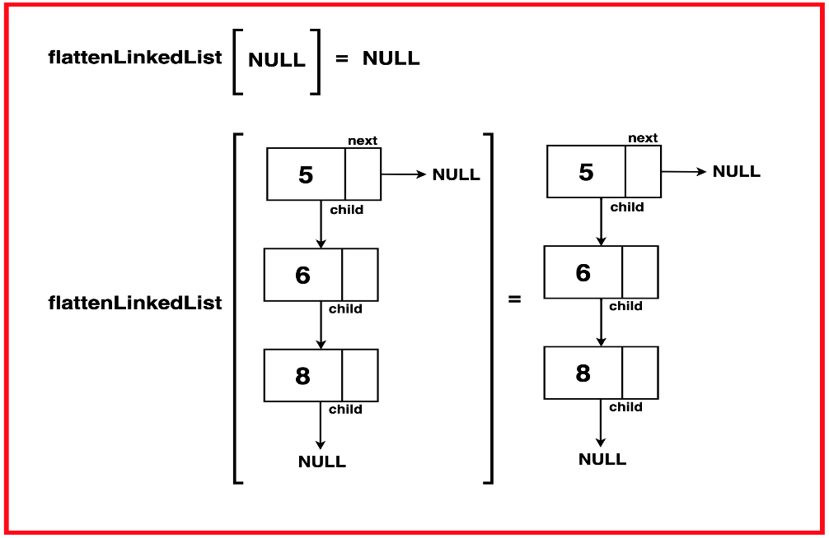
Recursive Function: The core of the algorithm lies in implementing a recursive function responsible for flattening the linked list. The function operates based on the principle that:
- If the base conditions are not met, the function invokes itself recursively. This recursion continues until it reaches the base case, gradually flattening the linked list and merging the resultant with the previous node.
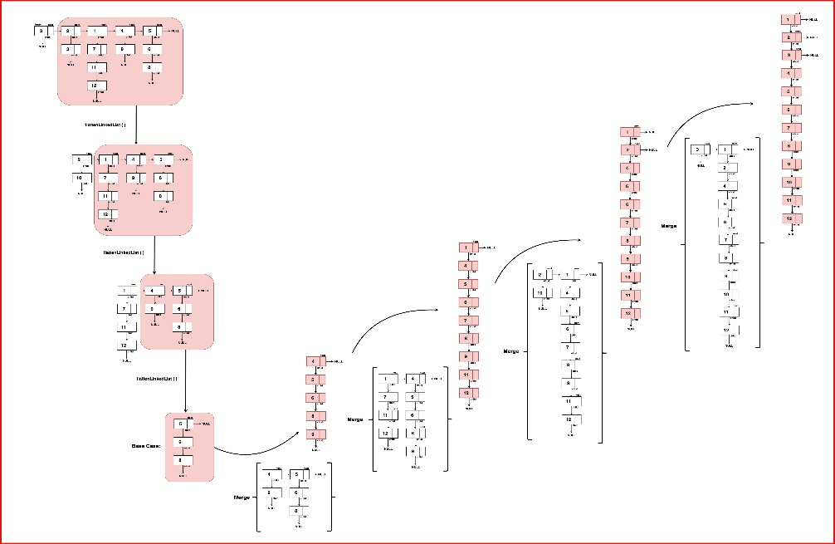
Return:Following the recursion, the function returns the merged head of the new flattened linked list. This head marks the new head of the merged list starting from the end, which will now be merged with the present head.
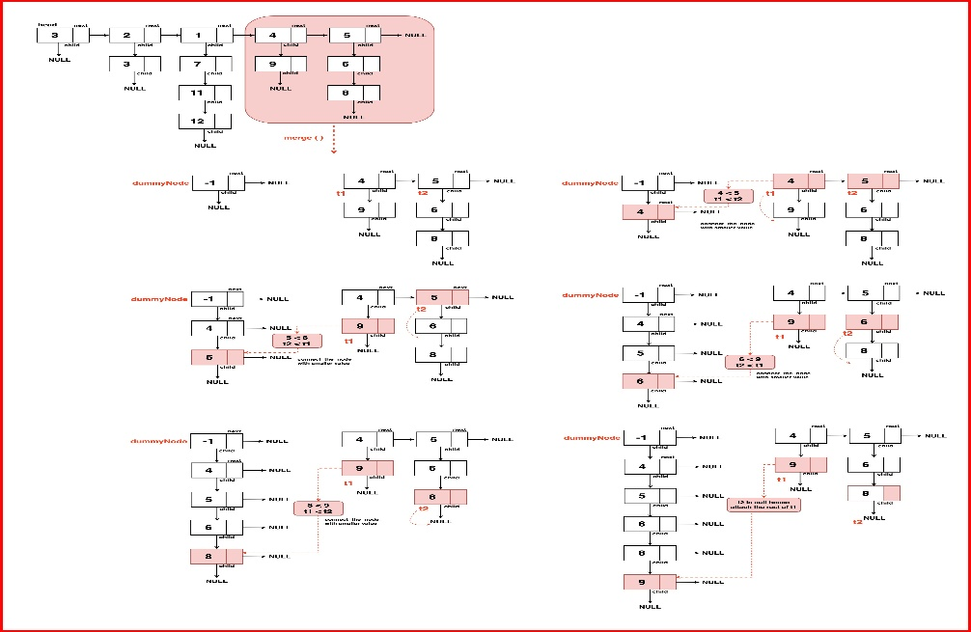
Step 1: Establish Base Case Conditions Check if the base case conditions are met, return the head if it is null or has no next pointer to head as there’s no further flattening or merging required.
Step 2: Recursively Merge the List:
- Initiate the recursive flattening process by calling `flattenLinkedList` on the next node (`head -> next`).
- The result of this recursive call is the head of the flattened and merged linked list.
Step 3: Merge Operations:
- Inside the recursive call, call the merge function which takes care of the merging of these two lists based on their data values.
- Read more about merging two linked lists here.
- The merged list is updated in the head, which is then returned as the result of the flattening process.
Code
C++JavaPythonJavaScript

class Node {
int data;
Node next;
Node child;

// Constructors to initialize the
// data, next, and child pointers
Node() {
this.data = 0;
this.next = null;
this.child = null;
}

Node(int x) {
this.data = x;
this.next = null;
this.child = null;
}

Node(int x, Node nextNode, Node childNode) {
this.data = x;
this.next = nextNode;
this.child = childNode;
}
}

public class FlattenLinkedList {
// Merges two linked lists in a particular
// order based on the data value
public static Node merge(Node list1, Node list2) {
// Create a dummy node as a
// placeholder for the result
Node dummyNode = new Node(-1);
Node res = dummyNode;

// Merge the lists based on data values
while (list1 != null && list2 != null) {
if (list1.data < list2.data) {
res.child = list1;
res = list1;
list1 = list1.child;
} else {
res.child = list2;
res = list2;
list2 = list2.child;
}
res.next = null;
}

// Connect the remaining
// elements if any
if (list1 != null) {
res.child = list1;
} else {
res.child = list2;
}

// Break the last node's
// link to prevent cycles
if (dummyNode.child != null) {
dummyNode.child.next = null;
}

return dummyNode.child;
}

// Flattens a linked list with child pointers
public static Node flattenLinkedList(Node head) {
// If head is null or there
// is no next node, return head
if (head == null || head.next == null) {
return head;
}

// Recursively flatten the
// rest of the linked list
Node mergedHead = flattenLinkedList(head.next);
head = merge(head, mergedHead);
return head;
}

// Print the linked list by
// traversing through child pointers
public static void printLinkedList(Node head) {
while (head != null) {
System.out.print(head.data + " ");
head = head.child;
}
System.out.println();
}

// Print the linked list
// in a grid-like structure
public static void printOriginalLinkedList(Node head, int depth) {
while (head != null) {
System.out.print(head.data);

// If child exists, recursively
// print it with indentation
if (head.child != null) {
System.out.print(" -> ");
printOriginalLinkedList(head.child, depth + 1);
}

// Add vertical bars
// for each level in the grid
if (head.next != null) {
System.out.println();
for (int i = 0; i < depth; ++i) {
System.out.print("| ");
}
}
head = head.next;
}
}

Output: Original linked list:
5 -> 14
10 -> 4
12 -> 20 -> 13
7 -> 17
Flattened linked list: 5 7 10 4 12 14 17 20 13
Complexity Analysis
Time Complexity: O( N*(2M) ) ~ O(2 N*M)where N is the length of the linked list along the next pointer and M is the length of the linked list along the child pointers.
- The merge operation in each recursive call takes time complexity proportional to the length of the linked lists being merged as they have to iterate over the entire lists. Since the vertical depth of the linked lists is assume to be M, the time complexity for a single merge operation is proportional to O(2*M).
- This operation operation is performed N number of times (to each and every node along the next pointer list) hence the resultant time complexity becomes: O(N* 2M).
Space Complexity : O(1) as this algorithm uses no external space or additional data structures to store values. But a recursive stack uses O(N) space to build the recursive calls for each node along the next pointer list.

